MAJOR PROJECT PROPOSAL
ON
Restaurant Management System

PROGRAM: BCIS
POKHARA UNIVERSITY

BY:
Prakash Majhi (16080033)
Rajina Dangol (16080038)
Nisha Pathak (16080028)
Sarishma Neupane (16080050)
Saurav Pokharel (16080053)

KATHMANDU, NEPAL
2019

Restaurant Management System

MAJOR PROJECT PROPOSAL

SUBMITTED TO
PROGRAM: BCIS
APEX COLLEGE
POKHARA UNIVERSITY
In partial fulfillment of the requirement for
BACHELOR IN COMPUTER INFORMATION
SYSTEM

SUBMITTED BY:
Prakash Majhi (16080033)
Rajina Dangol (16080038)
Nisha Pathak (16080028)
Sarishma Neupane (16080050)
Saurav Pokharel (16080053)
KATHMANDU, NEPAL

Abstract
This project titled as “Restaurant Management System” is developed in Php using HTML, bootstrap, JavaScript and CSS. We have used HTML, CSS, Bootstrap, JavaScript in front-end and MySQL server and PHP framework (Laravel) as back end. This is a concept of placing orders in a Restaurant via web application and reserving table from any places using the restaurant web application by the users. In this system the admin can login and store the food menu item, their price list and user as well as other admin information from the system. This system is developed to provide service facility to restaurant and also to the customer. This restaurant management system can be used by employees in a restaurant to handle the clients, their orders and can help them easily find free tables or place orders. The admin can access, add, update and delete the menu list of the restaurant as well as can view the number of order list they are getting and also can view the reservation of table done by the registered online user. This system also enables the delivery of food to the customers at desired location. Our system would also be enabled as a POS (Point of Sales) in the restaurant. The guest user can only view the menu provided by the restaurant and get detail about the restaurant by sending message to the restaurant. The user must be logged in to order the menu from the restaurant and the order places are sent to user cart for further information where the user can edit their order or delete the order as well as view the bill.

Table of Contents
Abstract i
Table of Contents ii
List of Figures ii
List of Abbreviation iii
Chapter 1 1
Introduction 1
1.1 Background 1
1.2 Scope 2
1.3 Project Description 2
1.3.1 Theoretical Knowledge 3
1.3.2 Overall Representation of the Project 3
1.4 Objectives 4
1.4.1 Academic Objectives 4
1.4.2 Other Objectives 4
CHAPTER 2 6
Literature Review 6
CHAPTER 3 7
Methodology 7
3.1 Hardware and Software Requirement 7
3.1.1 Hardware Requirement: 7
3.1.2 Software Requirement: 7
3.1.3 CPU 7
CHAPTER 4 8
Expected Outcomes 8

List of Figures
Figure 1 Context Flow Diagram 3
Figure 2 Use Case Diagram 4

List of Abbreviation
- AJAX: Asynchronous JavaScript And XML
- CSS: Cascading Style Sheet
- DBMS: Database Management System
- GIT: Global Information Tracker
- HDD: Hard Disk Drive
- HTML: Hyper Text Markup Language
- PHP: Hypertext Preprocessor
- ROM: Read Only Memory
- SQL: Structured Query Language

Chapter 1

Introduction

1.1 Background
Restaurant Management Systems are the crucial technology components that enable a single outlet or enterprise to better serve its customers and aid employees with food and beverage transactions and controls. A point of sales system is either a stand-alone machine or a network of input and output devices used by restaurant employees to accomplish their daily activities including food and beverage orders, transmission of orders to the kitchen and other areas, guest settlement checking, mobile payment, and charge posting folios.
Restaurant Management System is a web application to manage the restaurant business. This system is developed to automate day to day activity of a restaurant. Restaurant is a kind of business that serves people all over the world with ready-made food. This system is developed to provide service facility to restaurant and also to the customer. This restaurant management system can be used by employees in a restaurant to handle the clients, their orders and can help them easily find free tables or place orders. The Restaurant Management System helps the restaurant manager to manage the restaurant more effectively and efficiently by computerizing billing, report generator and sales management. The users can do online payment through IME Pay, khalti app or mobile payment otherwise they can also prefer cash on delivery.
Many restaurants have a lot of difficulty in managing the business such as customer ordering and table reservation. By using manual customer ordering it is difficult for the employee to keep the correct customer information and may lose the customer information. Nowadays, many restaurants manage their business by manually take customer order with the use of paper. This is problem for restaurant waiter that there is probability of duplication of information. Additionally, it would affect the reputation of restaurant in operation management. Sometimes, waiter information and customer information is important to restaurant administrator for reference in the future.
The best way to optimize these activities is growing the business online as well. Today’s generation encourages high-tech services especially over the internet. Hence, this project is developed proficiently to help restaurant owners automate their business operations. This project serves the best way of maintaining customer’s information and caters their needs.

1.2 Scope
Meanwhile in analyzing the project, there can be seen high demand of the management system in restaurant in today’s world. In our research we found most of restaurant lack the proper management system in their business activities. It was found that many restaurants are still using the manual system of ordering as well as billing in their daily business activities. It also triggers the fault records in their record book as many restaurants are facing the problem of taking the order from the people but the order are being placed to wrong people due to manual order recording. We visited many restaurants and small cafe’s where we found the record are being kept manually and even some of the restaurant using the excel sheet for recording their daily and overall sales of their business. As this system also enables the customer to do the online payment. So, with our research we found out that this kind of system in restaurant and café sector can enhance their operation activities smoothly and overcome all their function arising in their business lifecycle.

1.3 Project Description
The proposed project will be useful mainly for the restaurant businesses and customer who love to prefer the online food and pre-reservation of tables. Nowadays, people prefer the home delivery services for the food products as well as restaurant businesses use the manual system for booking of tables, customer orders. But, with the help of this management system it provides dedicated services to restaurant business as well as customer too. Besides these, the system lets you effortlessly manage your entire restaurant. The system operates flawlessly, making you more customer focused. It ultimately results in better user experience and the guests feel like visiting your restaurant again and again. Convenience is a key business driver in the hospitality industry, and the restaurant offering the convenience of table booking, payments and food options to the guests get more customers too.

1.3.1 Theoretical Knowledge
In order to complete this project, we required some theoretical knowledge about the internet technology and about its components and networking like HTML, Laravel, Git Bash, CSS, Javascript, jQuery (AJAX). For the storage
management of the data of the proposed system we also have knowledge about database management like MySQL.
The system will be developed on the PHP as a backend programming language using Laravel framework to interact with the database and store the information as well as develop the functionality of the use of the system effectively. Bootstrap and CSS (Cascading Style Sheet) will be used for designing of this project. Bootstrap will help to build the framework for this system with adding PHP function to support the framework with a dynamic website pattern. CSS will help in designing the framework and beautifying to the bootstrap layout of the project.

1.3.2 Overall Representation of the Project
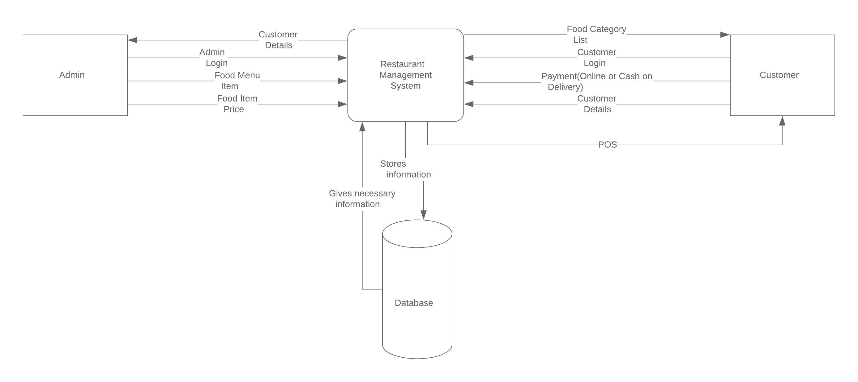
Figure 1 Context Flow Diagram
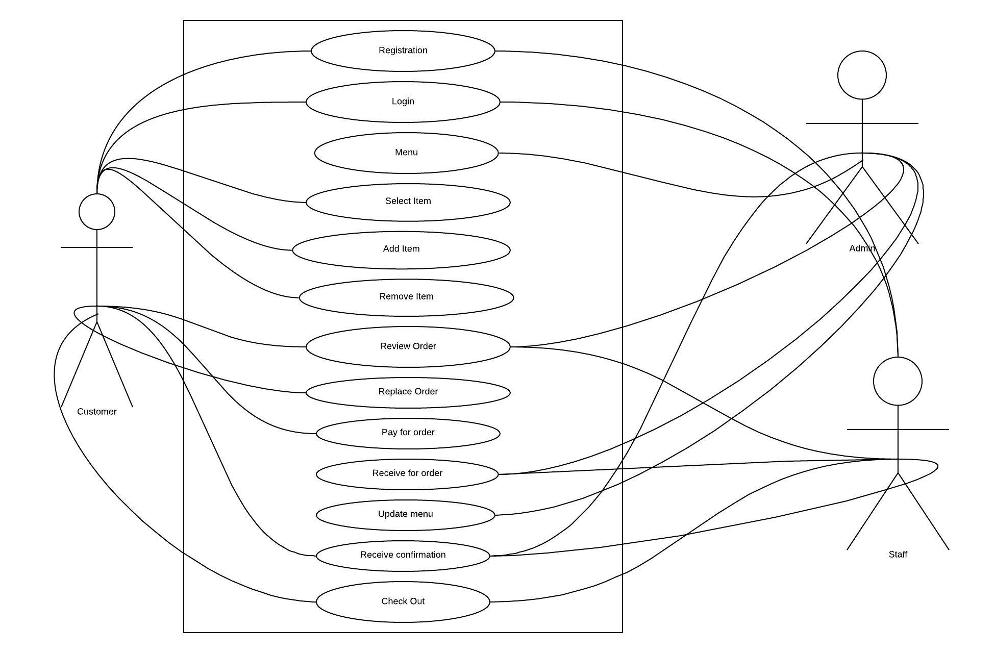
Figure 2 Use Case Diagram

1.4 Objectives

1.4.1 Academic Objectives
The following are the academic objectives of the project:
- To complete the minor-project we mentioned by the university in a specified time.
- For the partial fulfillment of requirement for the degree of BCIS.
- To learn about time management and explore more on group work with environment.
- To improve skill in information technology and database management system.
- To encourage and motivate team members.
- To utilize the theoretical knowledge and bring it into practical form.
1.4.2 Other Objectives
The following are the specific objectives of the project:
- To learn about the real time working of web development fundamental concept.
- To develop a viewable platform on any devices with 100% responsiveness.
- To develop a web-based application, which can easily and effectively manage ordering and billing of food items.
- To help reduce manual, repetitive and paperwork.

CHAPTER 2

Literature Review
Restaurant Management System, a proper and systematic system which deals with the management activities of the restaurants in this competitive 21st century. We came to know about this project after visiting the renowned restaurant and café Red Mud Café. We visited there for our refreshment and we got to know that they have digital way of taking order from the customer and digital billing view for the customers.
By seeing the management service at the Red Mud Café we were inspired and decided to do this project and implement in real time for the restaurant those who are seeking for the systematic and easy way of providing their services to the people within their business place as well as out of their business area like home based order. We want to develop this system to make the restaurant business to operate smoothly and customer to get enough satisfaction as well as help the restaurant to operate in the competitive market and sustain for a long period of time. This system gives its user an easy way to perform their tasks effectively.
For making this project, we surveyed many restaurant and café to know whether any of them has used this system. But we got to know that only few renowned restaurants are using these kinds of system but they lack the online order system in their used system. In development of this project, we need to know all the components that are attached to restaurant in order to include in the new system so that user can feel easy to operate with this system.
For the further enhancement, we are searching for more features and conducting more research in order to build this system effectively with more features.

CHAPTER 3

Methodology

3.1 Hardware and Software Requirement

3.1.1 Hardware Requirement:
- Keyboard
- CPU
- Monitor
- Mouse
- Internet Connection

3.1.2 Software Requirement:
- Operating system: Windows 7 and above
- Front end tools: HTML, PHP, CSS, Bootstrap
- Back end tools: MySQL, DBMS Server

3.1.3 CPU
- Processor: Intel Dual Core and above
- RAM: 4GB
- HDD: Minimum 500MB of available hard disk

CHAPTER 4

Expected Outcomes
This system is designed and developed to provide an easy interface in simple manner for the restaurants and online customer as well as visiting customer in restaurant. This is a system that will able to store customer’s information, employee information, menu’s information, reservation information and online ordering information. This system generates sales and profit business report for the restaurants. It includes the information about the different outlay it has in particular city. The roles are assigned to the staff of the asper their assigned task and duty in the restaurant.
The customer can register and place online order from the restaurant and choose the desired payment system for pay service. For regular customer, they can make the payment from their table with option like mobile-payment and IME Pay and many further options like paypal, khalti as well as cash. The restaurant employees can use the system as per their roles assigned to them. The manager can view all the orders, report, customer details, employees’ details and it can be said that s/he will have maximum access than of other staff. The kitchen staff can only view the order and set the desired time to complete that particular order. Whereas, cashier can have access to the order, billing system, payment receive and return.
This system will be full of online ordering system for a particular restaurant as well as POS (Point of Sale) system for visiting customer to restaurants. This system helps to completely change manual system of operation to computerized system.

